ASEM Education 2030

Action Plan (Draft 2)

Table of Contents

1. Introduction 1
2. Overview of the Strategic Objectives and Subgoals 1
3. Actions, projects and initiatives 4
4. Structure and Organisation of the ASEM Education Process 22
4.1. Two-year Meeting Cycle 22
4.2. Main Actors of the ASEM Education Process 22
5. Planning and Monitoring of the Action Plan 24

- Introduction
This Action Plan embodies the practical implementation of the ASEM Education Strategy 2030 as it lists actions that ASEM Education partners and stakeholders are carrying out and are planning to carry out to realise the ambitions of the ASEM Education Strategy and reach the four strategic objectives identified for the next decade.
Through exchange and collaboration, Ministers, senior officials, policy makers, experts, researchers and stakeholders’ representatives all have a role to play: pooling resources, identifying synergies and strengthening ties with relevant partners and stakeholders are at the heart of this action plan.
The Action Plan is divided in four parts. The first part provides an overview of the four strategic objectives and subgoals identified in the ASEM Education Strategy 2030. Each objective is associated with a pictogram for easier reading.
The second part specifies different actions to implement to realise these four objectives. Existing ASEM Education projects, activities and initiatives are listed under each action, together with suggestions and ideas for new projects or initiatives.
The third part of the action serves as a reminder of the existing structure and organisation of the ASEM Education Process, in which projects and initiatives will be further developed and implemented, and briefly presents the different actors and supporting structures and institutions and their role.
Finally, the last part details how the monitoring of the Action Plan will take place.
This Action Plan is a living document: relevant projects can be added and new stakeholders can be involved at a later stage should ASEM Education partners and stakeholders find it appropriate.

- Overview of the Strategic Objectives and Subgoals
This section provides an overview of the four strategic objectives and corresponding subgoals as outlined in the ASEM Education 2030 Strategy Paper. Coloured pictograms and numbers are associated with each objective and subgoal to facilitate reading of the table included in the following section.

Strategic Objective 1: Enhancing Connectivity between Asia and Europe by Boosting Inclusive and Balanced Mobility and Exchanges

To implement and promote physical mobility programmes with an equal balance between Europe and Asia and special attention for inclusive access to mobility

To boost inclusive blended and virtual programmes for mobility and exchange between Europe and Asia

Strategic Objective 2: Promoting Lifelong Learning (LLL), Including Technical and Vocational Education Training (TVET)

To raise the profile of LLL and TVET
To collaborate with business and industry

Strategic Objective 3: Fostering a Skills’ Approach to Education and Training

To stimulate the development of transversal skills through mobility and exchange programmes between Europe and Asia

To promote and support skills for sustainable development in order to develop related values, skills and knowledge in Europe and Asia

To identify and promote supportive policies and good practices on the development of digital skills and on bridging the digital divide

3.4 To bring together expertise to anticipate the future demand for skills in both regions

Strategic Objective 4: Creating More Transparency and Mutual Understanding on Recognition, Validation and Quality Assurance

To improve transparency and mutual understanding to strengthen interregional cooperation, mobility and exchanges
To create transparency on validation and recognition mechanisms in order to promote and encourage the creation of personalised and relevant learning pathways

- Actions, projects and initiatives
Description of the action | Contribution to Strategic objective(s) and subgoal(s) | (New) AEP projects and initiatives | Activities and/or Milestones | Expected/Envisaged outcomes by 2030
- Continue and optimise existing ASEM Education Mobility Programmes |  | ASEM DUO Fellowship Programme (ASEM DUO Secretariat Korea) | Exchange of x pairs of students per year (ongoing)  Organise yearly Alumni meeting  Collect & disseminate testimonials to promote the ASEM DUO programme amongst partners and Stakeholders  Active outreach to European Partners to find commitment for contribution and tackle the imbalance between Asia and Europe  To be checked/completed by the ASEM-DUO Secretariat | More visibility on ASEM DUO Fellowship Programme and ASEM DUO programme  New ASEM partners taking part in the ASEM Duo Fellowship Programme and/or ASEM Work Placement Programme  X pairs of students and researchers are exchanged  To be checked/completed by the ASEM-DUO Secretariat
 |  | ASEM Work Placement (WPP) Programme (Flemish Ministry of Education/Thailand) | Promote the WPP amongst partners to find new (or renewed) commitment to contribute and provide scholarships  To be completed by WPP partners | To be completed by WPP partners
 |  | ASEF’s Education projects (Summer Universities, ASEF’s Students Forum, ASEF’s Young Leaders Summit,..)  (ASEF)  (ASEF Projects can be mentioned under different actions) | To be completed by ASEF | To be completed by ASEF
 |  | Asia-Europe Institute ASEM Summer School (AEI) | Implement yearly AEI Summer Schools for Asian and European Students, co-hosted by Asian and European universities using blended mobility formats  To be completed by AEI | Involving more students in AEI Summer schools by blended and virtual Summer Schools  X amount of students have attended AEI Summer Schools  To be completed by AEI
 |  | European Commission’s Higher Education Fairs (European Commission) | yearly Organisation of an HE Fair in Asia by EC-Delegations to promote European HE institutions in Asia  To be completed by the EC | To be completed by the EC
 |  | ESN Pilot project: Creation of local student organisations supporting international students in Asia (ESN) | To be completed by ESN | To be completed by ESN EC
- Identify or develop mobility opportunities between Europe and Asia under the funding programmes of partners and stakeholders |  | (NEW)  Provide updates on opportunities for ASEM Partners to take part in calls for Erasmus+, Erasmus Mundus, European Commission Capacity Building activities for Higher education, … (EC & AES) | Collect and promote calls for funding opportunities (AES’ communication channels)  Provide information sessions to interested ASEM partners and stakeholders on relevant calls  Provide a platform for ASEM Partners and stakeholders to identify project partners for applications | Existing Funding opportunities are used to set up collaborative projects and mobility schemes between ASEM partners
- Identify, collect and promote policies and good practices on inclusive mobility and exchanges (physical, blended and virtual) |  | (NEW)  Compile good practices, study ‘the state of the art’ of blended and virtual exchanges in the ASEM region (a dedicated working group? Expert Group Digitalisation? | Publishing and promoting good practices on inclusive blended and virtual exchange and mobility  Develop a forum or platform to share good practices, methodologies and approaches on virtual or blended exchange in ASEM countries.  To be discussed with Expert Group Digitalisation | ASEM Partners and Stakeholders have concrete ideas and inspiration to create blended and virtual exchange and mobility opportunities between Europe and Asia in an inclusive way  To be discussed with Expert Group Digitalisation
 |  | (NEW)  Promoting exchanges on inclusive mobility practices and policies through dedicated PLA's, conferences and seminars | Coordinator/ hosts for PLA’s/conferences/seminars to be identified
- Support the development of virtual exchange programmes, between Asia and Europe |  | (NEW)  Set up pilot projects for Collaborative Online International Learning (COIL) between Asian and European higher education institutions. (University Aschaffenburg-AEI?)  To be discussed with expert Group Digitalisation | Using pilot projects and its results to promote the COIL format (or other formats for virtual exchange) between Asian and European Institutions to ASEM Partners and Stakeholders  Develop models and provide lessons learnt for COIL projects between Asian and European Institutions  To be further discussed with University Aschaffenburg & Asia Europe Institute (University of Malaya)  To be discussed with expert Group Digitalisation | Models and guidelines are available to support HE Institutions in Asia and Europe in setting up Virtual exchanges/COIL programmes.  To be discussed with expert Group Digitalisation
- Develop, promote and support joint interregional research projects and networks |  | ASEM Lifelong Learning Hub (ASEM Lifelong Learning Hub Secretariat)  To be completed by LLL HUB | Promote ASEM LLL Hub: expanding membership, engage more researchers in networks, disseminate research publications and results.  Identify Asian host to take over the ASEM LLL Hub secretariat from UC Cork, Ireland. | 6 research networks providing evidence for policy makers on following themes:  To be completed by LLL HUB
(NEW)
Identify and promote interregional research grant programmes that can support interregional research collaboration between Asia and Europe (e.g.Marie Sklodowska-Curie Actions, Horizon Europe,…)

 |  | ASEM DUO Fellowship Programme (ASEM DUO Secretariat Korea) | Create more mobility opportunities for researchers under ASEM Duo. | ASEM Duo mobility opportunities are available for researchers
- Identify and promote instruments and tools to support lifelong learning policies, strategies & practices |  | ASEM Lifelong Learning Hub Research Network 4 (RN) on “National Strategies for Lifelong Learning” | To be completed by LLL HUB RN4 | To be completed by LLL HUB RN4
 |  | Promote the UNESCO Institute for Lifelong Learning’s (UIL) publications & tools on lifelong learning policy & practices | To be completed by UIL | To be completed by UIL
 |  | Promote learning cities’ activities, disseminate materials and encourage membership amongst ASEM countries.  To be completed by UIL | To be completed by UIL | To be completed by UIL
 |  | Promote the ETF self-assessment tool for Centres of Vocational Excellence, developed under the ETF network for Excellence (ENE). | Open up self-assessment tool, including analysis and peer exchange around the dimensions of VET excellence. | Increased cooperation on Vocational Excellence, including both thematic and sector-based cooperation.
- Collect and promote best and innovative policies, practices and success stories in lifelong learning including TVET |  | ASEM Education TVET Seminar (initiative to promote dialogue and share best practices and future perspectives in TVET)  (To be further discussed with Russia) | Conduct 2- yearly Peer-learning events dedicated to LLL and TVET.  (To be further discussed with Russia) | (To be further discussed with Russia)
 |  | ASEM LLL HUB: all Research Networks | To be completed by LLL HUB | To be completed by LLL HUB
 |  | (NEW)  ETF Network of Centres of Vocational Excellence (ETF)  https://www.etf.europa.eu/en/projects-campaigns/projects/network-excellence | Encourage membership of the ETF Network of Centres of Vocational Excellence among ASEM partners.  Widen the geographical reach of the ETF Network of Centres of Vocational Excellence by building partnerships with ASEM, especially Asian, countries. | Partnerships established with counterpart centres and networks.  Peer-learning with these centres; developed and shared tools in selected themes such as public-private partnerships, school autonomy, social inclusion and work-based learning
 |  | (NEW)  International Lifelong Learning Expert Roundtable (Institute for Adult Learning Singapore)  To be completed by IAL | 2-yearly implementation of international expert Roundtable on Lifelong Learning  To be completed by IAL | To be completed by IAL
 |  | (NEW)  UNEVOC Online Learning platform on ‘Bridging Innovation and Learning in TVET’ (BILT)  To be completed by UNEVOC | Online platform is available for ASEM partners and Stakeholders to share and learn from good practices on digitalisation, Industry 4.0, Greening TVET, entrepreneurship, migration  To be completed by UNEVOC | To be completed by UNEVOC
- Promote and support (interregional) workplace learning |  | Work Placement Programme (Flemish Community/Thailand) | Revitalise the Work Placement Programme by promoting the programme amongst partners and stakeholders (to discuss with Thailand & Flemish Community). | To be completed by coordinators WPP
 |  | ASEM LLL Hub, in particular RN2 on Workplace Learning | To be completed by LLL HUB RN2 on Worplace Learning | To be completed by LLL HUB RN2 on Worplace Learning
- Generate evidence to understand current labour market trends and influence future directions of LLL/TVET |  | (New)  Working Group/Network on Labour market & education monitoring (ETF) | Establishment of a working group on monitoring of VET in the context of the ETF’s monitoring and assessment work.  Invitation to ASEM members to join the ETF network of researchers focusing on skills anticipation and labour market analysis within the Skills lab. | An ASEM Network of researchers/research organisations is available that monitors education.  Increased joint projects and exchange of methodologies and practices turning into reinforced methods and methodologies for monitoring and assessment and research in the field of VET, skills anticipation and labour market analysis.
- Raising awareness amongst policy makers on the importance to integrate transversal skills in LLL policies, |  | (New)  Promote existing (regional) (policy) frameworks on transversal skills.  (New)  Collect and promote good policies on transversal skills enhancement in ASEM partner countries.
- Promote Education for Sustainable Development (ESD) |  | ASEF Projects (to discuss with ASEF) | Collect and promote good practices and cases on ESD in higher education institutions (e.g. UN Sustainability Certificate for Universities), on how to integrate SDG’s in universities’ policies & missions, concrete grassroots projects.  Promote ESD in Learning Cities and Regions.
 |  | IAU’s HESD Portal (to be discussed with IAU) | To be completed by IAU | To be completed by IAU
- Collect and formulate policy recommendations on digital infrastructure & digital skills (including bridging the digital divide) |  | Expert Group on Digitalisation (Position Paper) | To be discussed with the Expert Group Digitalisation | To be discussed with the Expert Group Digitalisation
 |  | ASEM LLL Hub Research Network 1 on “eASEM” | To be completed by the Research Network 1 on “eASEM” | To be completed by the Research Network 1 on “eASEM”
- Facilitate the comparison of ASEM countries’ higher education systems and create more transparency and understanding on different aspects of education systems in Asia and Europe such as: credit transfer systems, learning outcomes mechanisms, quality assurance systems, recognition and validation mechanisms, frameworks, micro-credential |  | Expert group on Credit Transfer Mechanisms and Learning Outcome systems | To be completed by the Expert group  (to include a focus on Microcredentials, digital credentialing?) | To be completed by the expert group
 |  | EU-SHARE Project and its results | To be completed by the SHARE Secretariat | To be completed by the SHARE Secretariat
 |  | ASEM Education Compendium on Higher Education | Completing the Compendium: regularly reaching out to missing countries;  Regular updates of the country contributions,  Promoting the compendium to partners & stakeholders  Identify opportunities for systematic exchanges and collaboration with similar databases (e.g. WHED) | Transparent and up to date information on all Higher Education Systems of ASEM partner countries are available and can be consulted by partners, stakeholders, HE Institutions and students.
 |  | Revitalise the ASEM Working Group on Bridging Declaration | To be discussed with the Chinese coordinator of the Bridging declaration
- Promote the use of existing relevant instruments and resources on (higher) education systems & qualification frameworks and provide data where necessary |  | Update and Promote the use of Global Inventory of Regional and National Qualification Frameworks | Publish and disseminate next edition of the Global NQF Inventory, in 2023. Achieve more widespread dissemination, through the new e-database, to ASEM members, partners and stakeholders. | New intelligence on NQFS and RQFs available.
 |  | Promote the use of UNESCO World Reference Levels | To be discussed with UNESCO | To be discussed with UNESCO
 |  | Promote ratification of the Global Convention on the Recognition of Qualifications concerning Higher Education 2019 amongst ASEM partners. | To be discussed with UNESCO | To be discussed with UNESCO
 |  | (NEW)  Compare and explore compatibility between the European Qualification Framework and ASEAN Qualification Reference Framework? (ETF)  To be further discussed with ETF/CEDEFOP/UNESCO & ASEAN Secretariat | To be further discussed with ETF/CEDEFOP/UNESCO & ASEAN Secretariat  Disseminate and draw on 2021 ETF study on regional qualifications frameworks, (RQFs), which includes analysis of ASEAN RQF:  https://openspace.etf.europa.eu/sites/default/files/2021-04/RQF%20initiatives%20around%20the%20Globe%202020_EN_April%202021%5B13%5D.pdf | To be further discussed with ETF/CEDEFOP/UNESCO & ASEAN Secretariat  Shared intelligence. Understanding among parties of how the levels of the respective frameworks correspond.
- Establish parallels between existing conventions and agreements for credit transfer and recognition |  | Revitalise the ASEM Working Group on Bridging Declaration  To be discussed with Coordinator of the Working Group | Monitor implementation progress of ANICs to promote best practices  Further enhance synergies between European and Asian networks of national centres for qualifications recognition  Promote and forge closer links with the Global Convention in conjunction with UNESCO and national centres  To be discussed with Coordinator of the Working Group | To be discussed with Coordinator of the Working Group
- Create transparency towards digital ecosystems related to digital credentialing including: quality assurance issues, transparency, interoperability between systems, individual digital learning records, learners’ rights, privacy, data protection and security issues, certification |  | (NEW)  Collect, map and promote good practices (national & regional systems or frameworks) for digital credentialing. (ETF)  (To be further discussed with the Expert Group Digitalisation) | (To be further discussed with the Expert Group Digitalisation)  ETF survey on use of digital/micro credentials in ETF partner countries. | (To be further discussed with the Expert Group Digitalisation)  Exchange of good practices in digitalisation and micro credentials.  Intelligence to inform advice to countries and regions on implications for reform of their qualification systems, notably in validation of nonformal learning, digitalisation and internationalisation of qualification systems and Regional Qualifications Frameworks.
 |  | (NEW)  Extension of ASEM Education Compendium on Higher Education with information about digital credentialing?  (To be further discussed with the Expert Group CTS) | (To be further discussed with the Expert Group CTS) | (To be further discussed with the Expert Group CTS)
(NEW)
Compare and create parallels between Asian and European infrastructures for digital credentialing.
(To be further discussed with the Expert Group Digitalisation)

- Create more transparency on quality assurance and recognition of MOOCs and other forms of online learning |  | ASEM Network of MOOCs  (To be discussed with K-MOOC Center, National Institute for Lifelong Education, Korea) | Encourage more ASEM countries to join the ASEM Network of MOOCs  (To be discussed with K-MOOC Center, National Institute for Lifelong Education, Korea) | (To be discussed with K-MOOC Center, National Institute for Lifelong Education, Korea)
 |  | (NEW)  Develop a ASEM Framework for quality criteria for online learning?  (To be further discussed with the Expert Group Digitalisation) | (To be further discussed with the Expert Group Digitalisation) | (To be further discussed with the Expert Group Digitalisation)
- Create policy awareness on the importance of flexible learning pathways & transitions in relation to labour market and societal needs |  | ASEM Lifelong Learning Hub Research Network 5 on “Lifelong Learning Transitions” | To be further discussed with LLL HUB RN5 | To be further discussed with LLL HUB RN5
(NEW)
Collect and promote good examples of systems and approaches for recognition and validation that support flexible learning pathways (e.g. individual LLL records).

- Increase the visibility of all of the above mentioned ASEM initiatives and projects and their results |  | ASEM Education Website (AES) | Regular updates on the website: News articles on ASEM Education and other relevant activities, publications, events,… Announcements of ASEM Education Events, documents,...  Making the ASEM Education Website more inclusive
 |  | ASEF Infoboard Website
 |  | ASEM Education Secretariat’s Newsletter
 |  | Twitter and LinkedIn posts by AES and ASEF
 |  | Informative video’s (AEP, AES)
NEW
Organizing events on ASEM Day

NEW
Developing video testimonials of students, ASEM partners & stakeholders for website, newsletter, social media

- Structure and Organisation of the ASEM Education Process
  - Two-year Meeting Cycle
Since its establishment in 2008, the ASEM Education Process (AEP) has been organised around a two-year cycle. Every two years the ASEM Education Ministers gather during the Ministers’ Meeting (ASEMME) to set the political and practical AEP agenda, which is then laid out in the Chair’s Conclusions of the ASEMME.
Ministerial meetings and this agenda are prepared by the Intermediate Senior Officials’ Meeting (ISOM) and two Senior Officials’ Meetings (SOMs) during which senior officials and stakeholders discuss the policy orientation of the AEP, as well as existing and potential future projects, initiatives and activities. All meetings are hosted by a Ministry with the support of the ASEM Education Secretariat (AES).
This Action Plan, approved by the Education Ministers during ASEMME8, will set out the framework for the practical implementation of the ASEM Education Strategy 2030 and will serve as basis to develop the two-yearly work plan that will be outlined in the Chair’s Conclusions.
  - Main Actors of the ASEM Education Process
    - Policy Makers and Stakeholders
The Asia-Europe Meeting and the ASEM Education Process are informal political fora in which policy makers and stakeholders work together based on mutual trust and respect.
Policy makers involved in the AEP are mostly senior officials, ministers and their representatives from Ministries of Education and/or Ministries of Higher Education from all ASEM partners countries. Their expertise and policy responsibilities mainly lie in the field of international cooperation in (higher) education. Policy makers are involved in political meetings (SOMs, ASEMMEs), as well as in projects and initiatives within the ASEM Education Process.
Most ASEM Education initiatives, programmes and projects are coordinated and implemented at stakeholder level. There is a lively interaction between the political and the stakeholder level: both policy makers and stakeholders take part in initiatives, conferences, working and expert groups organised by stakeholders while stakeholders contribute their views and expertise to the policy debates and are invited to attend policy meetings (e.g. I/SOMs, ASEM ME).
The term “stakeholders” refers to all institutions, organisations, interest groups, etc. who are involved in the ASEM Education Process or have an interest in its success but are not official partners (= Ministries of Education) of ASEM. The most active stakeholder in the AEP is the Asia-Europe Foundation (ASEF), the only permanent institution of ASEM. Other stakeholders currently involved in the ASEM Education Process are: Asia-Europe Institute (AEI), ASEAN University Network (AUN), ASEM Lifelong Learning Hub Secretariat (University College Cork), ASEM-DUO Secretariat, European Association of Institutions in Higher Education (EURASHE), Erasmus Student Network (ESN), European Centre for the Development of Vocational Training (CEDEFOP), European External Action Service (EEAS), European Quality Assurance Register for Higher Education (EQAR), European Student Union (ESU), European Training Foundation (ETF), European University Association (EUA), German Academic Exchange Service (DAAD), International Association of Universities (IAU), SEAMEO RIHED and UNESCO.
The list of stakeholders is not restrictive; organisations or institutions with relevant projects or initiatives, which contribute to the Strategy 2030’s strategic objectives, can be included to this list in the future.
    - Supporting Institutions and Structures
To implement the wide range of projects and initiatives outlined in the Action Plan and realise the ambitions of the 2030 Strategy, ASEM Education partners and stakeholders can count on the permanent support of the following existing institutions and structures and their capacities.
ASEM Education Secretariat
The ASEM Education Secretariat (AES) was established during ASEM Ministers of Education during ASEMME2 in 2009 to ensure effective coordination of ASEM Education Process initiatives and projects. In addition to its coordination role, the AES facilitates ASEM Education activities, represents the ASEM Education Process during regional and international events and liaises on a regular basis with existing and potential partners and stakeholders to identify synergies and initiate collaborations. The AES is at the heart of the ASEM Education community, it contributes to institutional memory and coherence between initiatives to avoid duplication. Asian and European countries take turns hosting the secretariat every four years on a voluntary basis to guarantee the continuity of the ASEM Education Process.
The Asia-Europe Foundation (ASEF)
The Asia-Europe Foundation (ASEF) is an intergovernmental, not-for-profit organisation which brings together the people of Asia and Europe to address common global challenges. It is the only permanent institution of the Asia-Europe Meeting political dialogue process and is publicly funded by voluntary contributions from the 53 ASEM partners. Education is one of ASEF’s key thematic areas. By connecting youth, students, teachers and educators, higher education leaders and experts with policy makers across both regions through different projects, ASEF contributes significantly to the strategic objectives.
ASEM Lifelong Learning Hub Secretariat
The Secretariat of the ASEM Education Research Hub for Lifelong Learning coordinates a platform for dialogue between researchers, practitioners and policy-makers composed of six thematic research networks. The ASEM Lifelong Learning Hub and its Research Networks shall play a significant role in building robust engagement between researchers, policy makers and stakeholders, in identifying research topics and translating research results into policy recommendations, thereby contributing to the four strategic objectives.
ASEM-DUO Secretariat
The ASEM-DUO Secretariat based in Korea coordinates the ASEM-DUO Fellowship Programme, one of the flagship initiatives in the ASEM Education Process that contributes to balanced mobility between Asia and Europe. The mission of the ASEM-DUO Secretariat is to serve as a focal contact point and depository for relevant information about the programme. Minimum coordination among individual DUO programmes is indispensable in order to maintain consistency and avoid duplication, as well as to maximise its effectiveness and minimize the cost of its implementation. The secretariat may also serve, depending on each country's needs, as a center for the receipt and processing of applications. As of now, seven ASEM countries are financially contributing to the balanced mobility through ASEM-DUO fellowship programs which are Belgium, Germany, India, Republic of Korea, Singapore, Sweden, and Thailand.

- Planning and Monitoring of the Action Plan
The ASEM Education Secretariat (AES), in close interaction with the coordinators of the projects and initiatives and with the support of the Standing Working Group, will be in charge of monitoring the implementation of this action plan and assess to which extent activities and projects carried out have contributed to the four strategic objectives formulated in the ASEM Education Strategy 2030.
Every two years, ASEM Education partners and stakeholders will update each other on their future plans through the Chair’s Conclusions presented and endorsed during the ASEM Education Ministers' Meeting (ASEMME). The annex of the Chair’s Conclusions will serve as a work plan for the next two years and will detail concrete plans for activities under each project or initiative. It will also specify expected outputs and results and explain how partners and stakeholders’ activities contribute to the strategic objectives.
Finally, the Stocktaking Report, published every two years by the AES, will be the main instrument for monitoring the implementation of the ASEM Education and progress of activities listed in this Action Plan. Senior officials, partners and stakeholders are expected to actively contribute to this report by providing regular updates on their on-going activities to the AES.
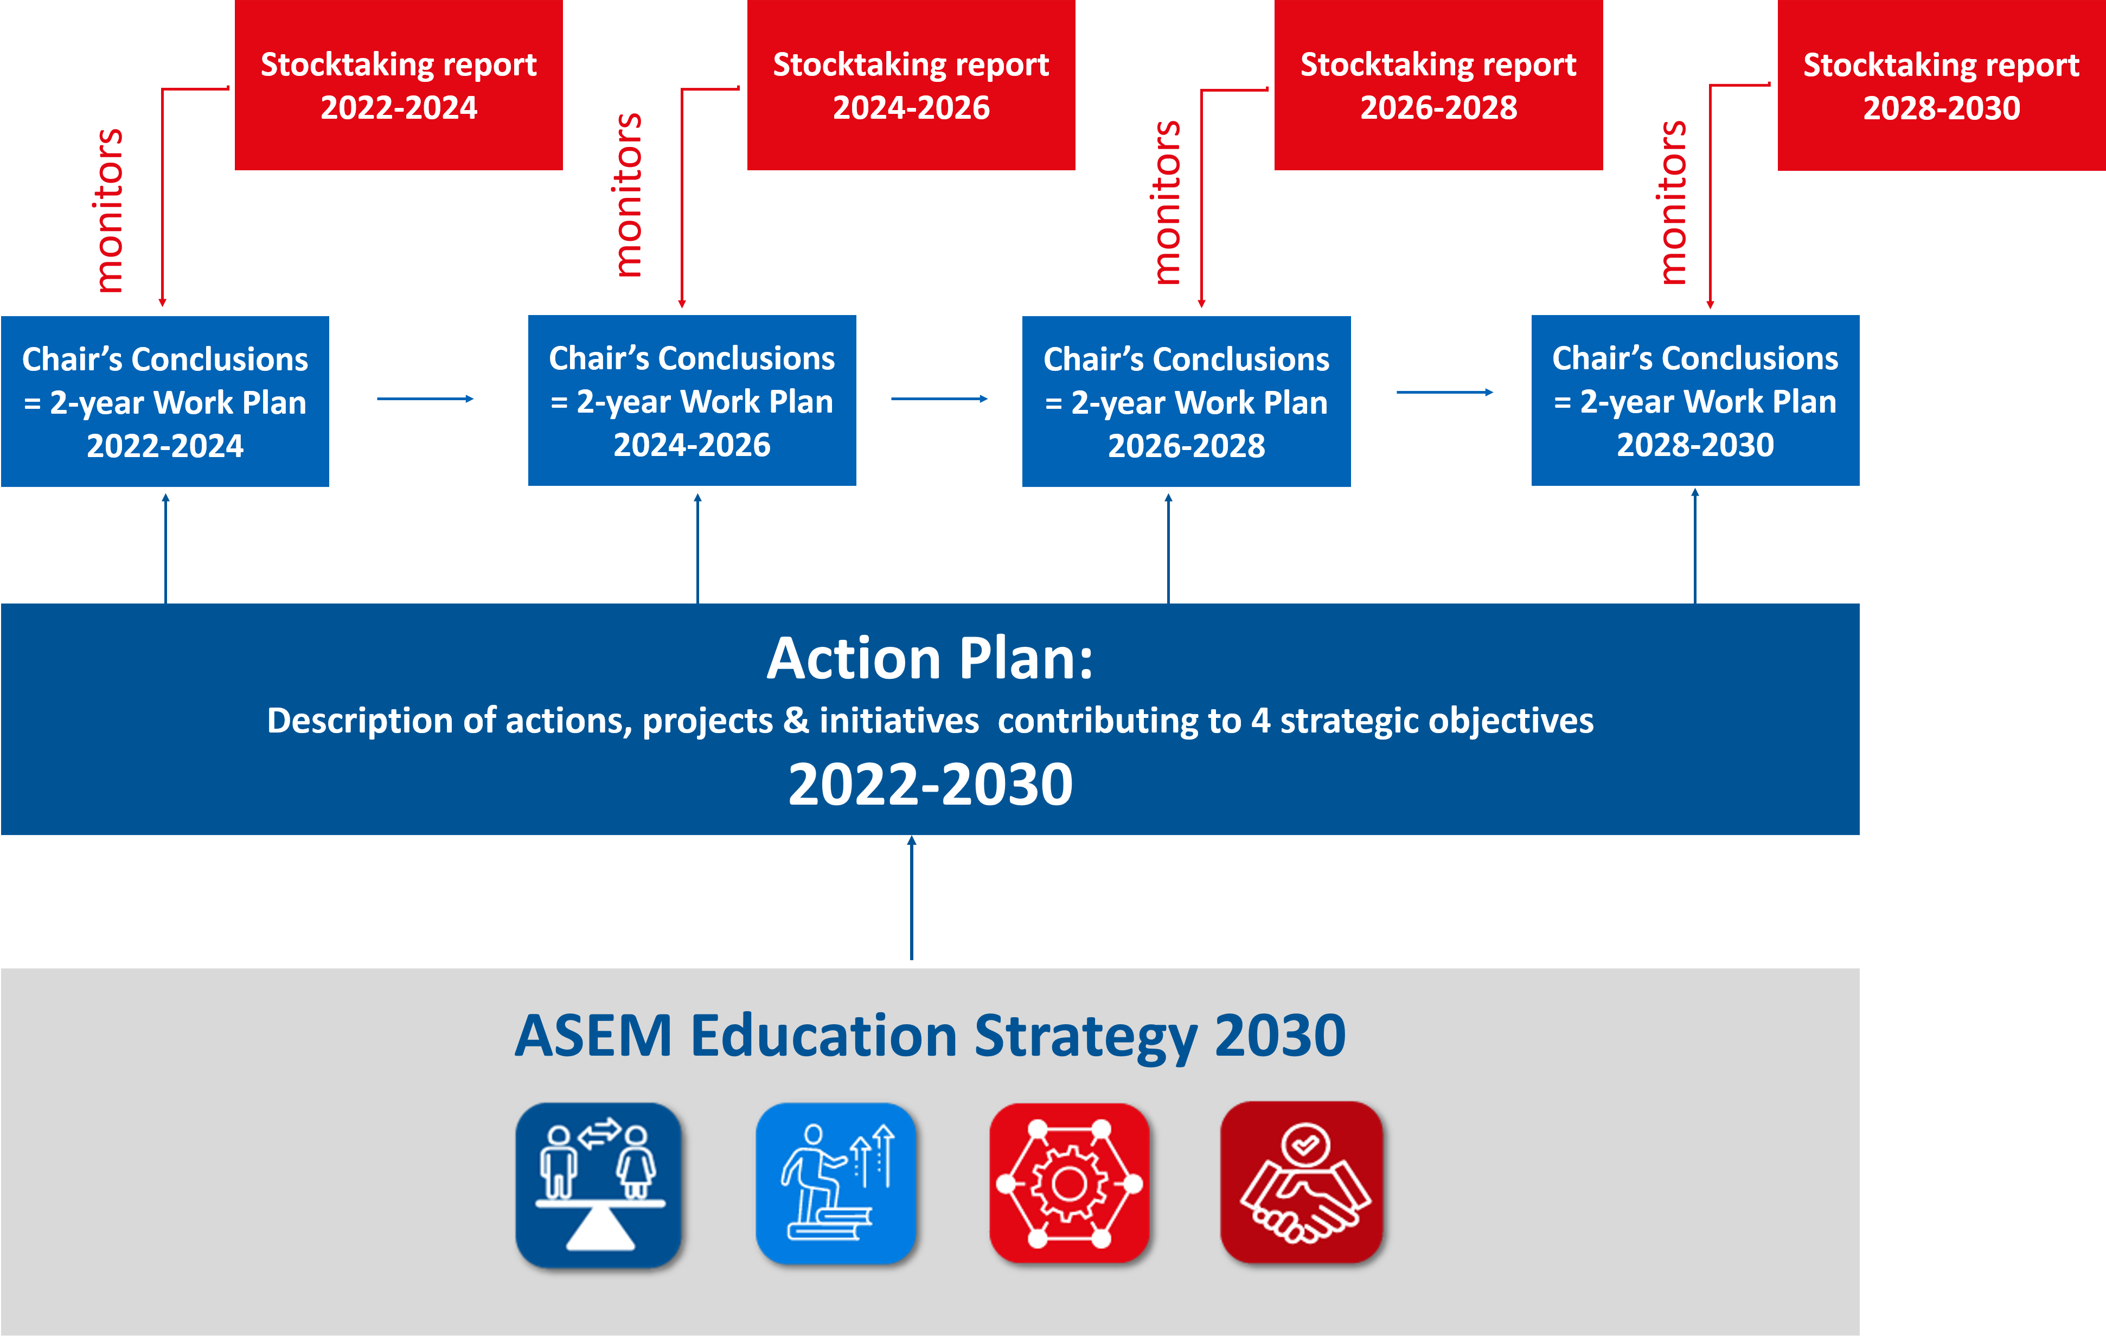

- The ASEM Education Process as a Multilateral Forum in a Wider Ecosystem
The ASEM Education Process is part of a wider ecosystem involving a large network of international actors and organisations. In the next decade, closer cooperation and dialogue will not only be fostered and reinforced with existing ASEM Education partners and stakeholders, but will also be encouraged with other relevant multilateral processes and organisations, such as the Bologna Process (especially in the framework of the Bologna Global Policy Forum), Asia-Pacific Economic Cooperation (APEC), Asian Development Bank (ADB), Organisation for Economic Co-operation and Development (OECD), the Groningen Declaration Network (GDN), as well as quality assurance and recognition bodies (e.g. European Association for Quality Assurance in Higher Education (ENQA), ENIC-NARIC network). This list is not exhaustive nor set in stone; ASEM Education partners and stakeholders will continually seek to connect and exchange with other multilateral actors and fora where relevant.
ASEM Education partners and stakeholders will seek to make the best use of existing resources and contribute to relevant initiatives, tools or publications and, where possible, emphasise the Europe-Asia dimension. Furthermore, special attention will also be devoted to better communication on ASEM Education Process’s activities, projects and initiatives in order to identify potential synergies and strengthen relationships with multilateral actors sharing similar goals and priorities.
Finally, ASEM Education partners and stakeholders will seek to create more opportunities for dialogue and systematic exchanges with the overall ASEM Process. Dialogue between both processes should be enhanced by regular updates on each other’s activities and exchanges of relevant documents and materials. In the future, a point on the agenda of senior officials’ and ministerial meetings could be dedicated to an update on the state of play of ASEM Foreign Ministers’ activities. This should not only lead to increased visibility of ASEM Education activities, projects and initiatives within the overall ASEM Process, but also to more coherence between both processes.

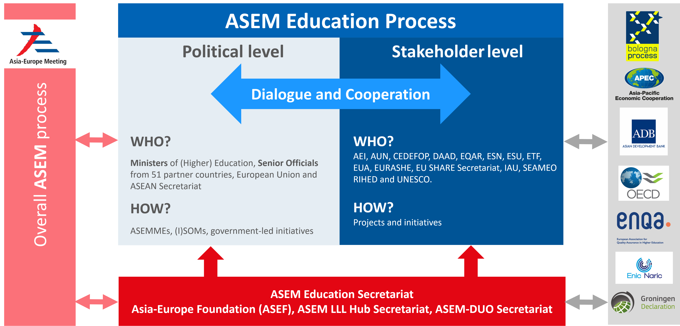

List of stakeholders to be added?
51 partner countries, 2 institutional partners (the European Union and the ASEAN Secretariat), AEI, ASEF, ASEM-DUO Secretariat, ASEM LLL Hub Secretariat (University College Cork), AUN, CEDEFOP, DAAD, EQAR, ESN, ESU, ETF, EUA, EURASHE, EU SHARE, IAU, SEAMEO RIHED and UNESCO.

